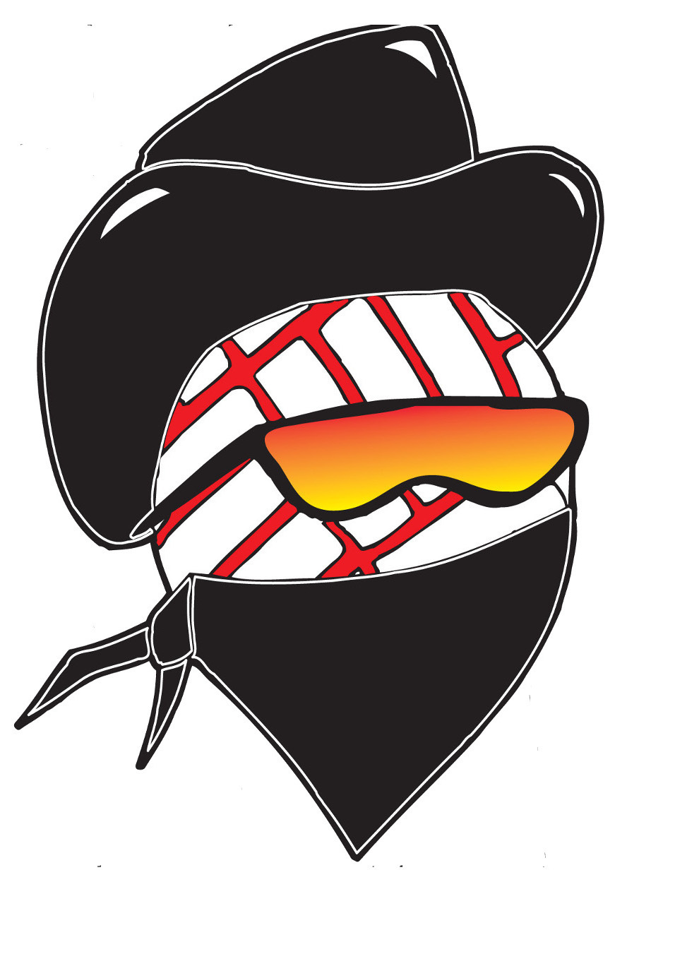

DALTON GANG

2 HANNAH MCKIE 5-5 S 2026 ROCKDALE HS
4 CAROLYNA NEIHEISER 5-3 L 2027 THRALL HS
5 ELENA MARTINEZ 5-8 M/RS 2026 TAYLOR HS
6 EMERY HUNEYCUTT 5-8 H/RS 2027 HUTTO HS
7 ASHLYN CARPENTER 5-9 M 2026 MCDADE HS
9 EMMA MIRALLES 5-8 H 2027 HUTTO HS
11 KEELIE JACKSON 5-8 M/H 2027 THRALL HS
13 ISABELLA SLAUSON 5-5 S 2026 THRALL HS
15 ADRIANA FLORES 5-11 M 2026 ST MARY’S HS
21 MIA DUNNE 5-6 H 2026 ELGIN HS

Head Coach Ronnie Kaase
Assistant Coach Abbie Leonard

